Dear poets,
My dream project each year is to share student poems for Science Week (15-23 August) on the Science Rhymes website. This year, National Science Week is supporting my call for OCEANS OF POETRY from EVERYONE – not just school students. Click on the blue links for more details, then submit your poems by 31st July. I really hope you will join in … and please share this request with anyone you think may be interested.
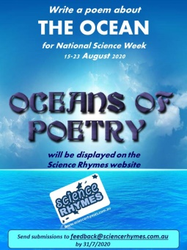
Snapping Surprises by Celia Berrell
(beware the globiferous pedicellariae)

Spiky-round sea-urchins
live in the ocean.
Grazing on algae
in graceful slow-motion.

As well as their prickles
providing protection
against hungry fish
they’ve another invention.

Free-floating jaws
that have venomous fangs
can break-off some urchins
like guard-dogs in gangs.

These jaws may be tiny
but fish soon get wise.
They all hate the pain of
an urchin surprise!
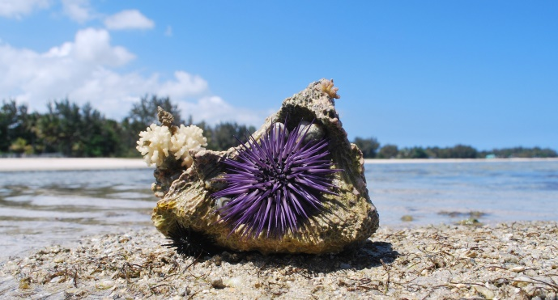
https://www.abc.net.au/news/2017-04-28/sea-urchin-discovery/8480322

